# WELCOME

Ms.

Ayaka

MAEMURA

Flight Arrival Date: 06 Apr 2019 Flight Arrival Time: 09:30 Flight Number: QF26

Homestay Address: Angela YAKOUMELOS , 8/11-17 Burleigh Street, Burwood, NSW, 2134

Mobile: 0412 435 650

Once you arrive at Darwin Airport

When you come out of Customs, please wait for your host outside the gate (check the map circled in red) where your driver/host will wait for you there

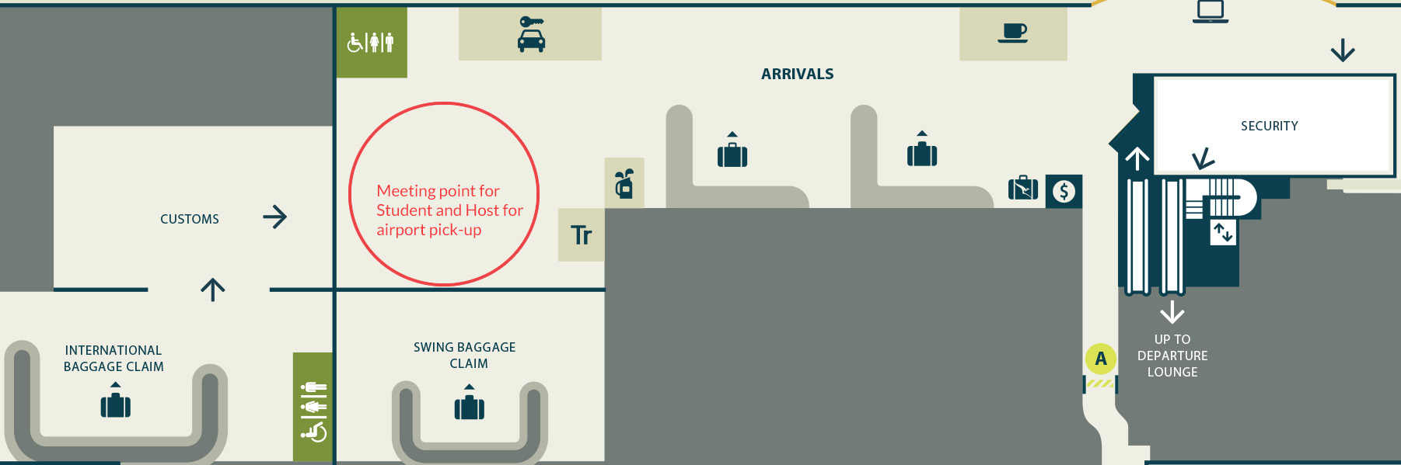

In case of Emergency please contact:

Your Host: 0415 375 005

Global experience Emergency Number: (+61) 430 008 448

PLEASE DO NOT LEAVE THE AIRPORT, WAIT FOR YOUR DRIVER